Task 2.5:

Models:

The models that I defined in my project are as follows

1. Recipe
2. Ingredient
3. RecipeIngredient

Model Changes:

Previous Model:

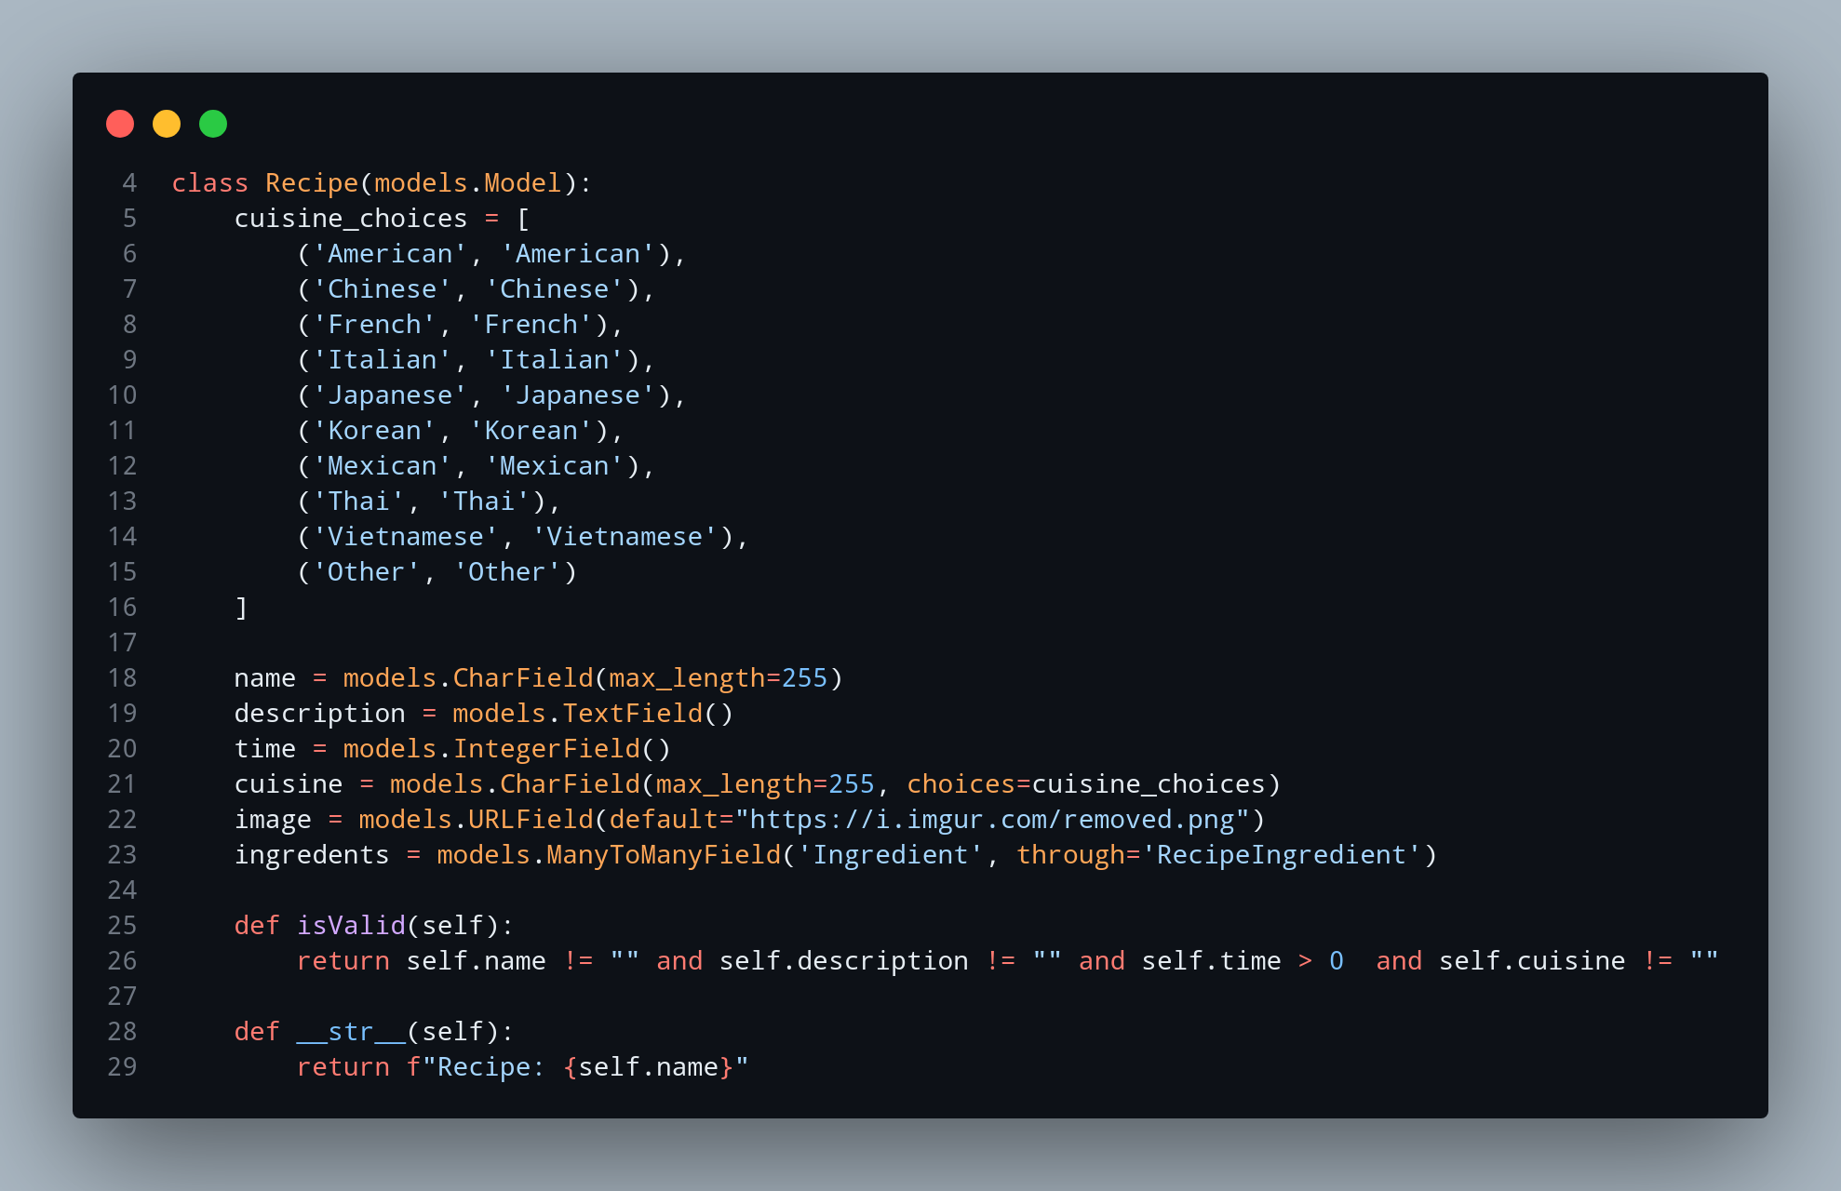

In my previously made model, as can be seen above, I was using a URL Field for the recipe images. After the reading in Task 2.5, I got to know about the Image Field in Django and how it works. So I am now changing it from URLField to ImageField so that users of the app can now directly upload an image instead of providing a link for it.

Current Model:

